TC Cockpit Enterprise Dashboard Update Assembly 1 Deployment Guide

Revision History
Author | Revision Number | Date
TCSASSEMBLIER | 1.0 | Jul/8th/2011

Deployment Instructions 3
1. Organization of Submission 3
2. Application Setup 3
2.1 Configuration file setup 3
2.2 Build scripts setup 5
3. Database Setup 5
4. Deployment Instructions 5
5. Starting 5
6. Verification 6
7. Resource Contact List 9

Deployment Instructions

Organization of Submission

The submission has following directory structure:

docs

Contains this document which is the Deployment Guide for the TC Cockpit Enterprise Dashboard Update 1 assembly.

direct

Contains all the updated and newly added sources files, statis files and configuration files for the topcoder direct application

test_files

Contains SQL script and linux script used to test the assembly

db_scripts

Contains the new queries for the assembly

Application Setup

The application is expected to be deployed to the following environment:

JRE 1.5
JBoss 4.2.3.GA
Informix DS 11.0

Configuration file setup

None

Build scripts setup
The build script for Direct application (build.xml) provides the following targets which are to be used:

- switch-and-checkout –checkout or switch to the defined source code branches for all components defined in subprojects.xml
- dist-backend –rebuilt all the components from the source code.
- first_deploy –must be the first task to execute from command line. It will copy all dependencies to your local JBoss folder.
- deploy –should be the main task to execute from command line. It will build and deploy WAR file.
- deploy-apache-static –deploys the static files to jboss.

You can get more information here:
http://www.topcoder.com/wiki/display/docs/TC+Direct+Setup+Guide

Database Setup
There is one new query introduction in this assembly called direct_dashboard_enterprise_summary

- To access the TopCoder Query Tool, make sure your VM is running and configure correctly and access http://tc.cloud.topcoder.com to login first (usr:heffan / pwd : password).
- After login, you can access http://tc.cloud.topcoder.com/query/query to create the new query:
  - The new query are all put under db_scripts directory
  - You should select TCS Data Warehouse in the DB selection of query tool
  - Click new command to create a new command called direct_dashboard_enterprise_summary, select the group Statistics, then save.
  - Click New Query to create the new query, the content of the query is in the SQL file mentioned before:
Query name | SQL file name | Description
direct_dashboard_enterprise_summary | db_scripts\direct_dashboard_enterprise_summary.sql | This query will be used by the DataProvider to get the min and max contest cost and duration of customer and market

The new query has following inputs needed to be adding when creating the new query:
- tdpis
- bpids
- clids
- sdt
- edt
- pcids
  - Add the newly created query to the newly created command

Deployment Instructions

This section provides the instructions in Production environment.

- Merge the code from submission into SVN branch for Direct application
- Build and deploy Direct application using ant deploy (or ant first_deploy ) command.
- Copy static files using ant deploy-apache-static command.

Starting

- Build and deploy the Direct application
- Start JBoss server instance hosting Direct application

Verification

Before testing, please update your hosts file with
<Your VM IP> tc.cloud.topcoder.com tcs.cloud.topcoder.com, this is the IP of test VM server

After deploy and the JBOSS is successfully started. Log in into the Cockpit via the page http://cockpit.cloud.topcoder.com/direct/. After log in, go the http://cockpit.cloud.topcoder.com/direct/dashboardEnterprise.action, as in the default date range there is no test data inserted, you will see N/A displayed for the enterprise dashboard summary panel

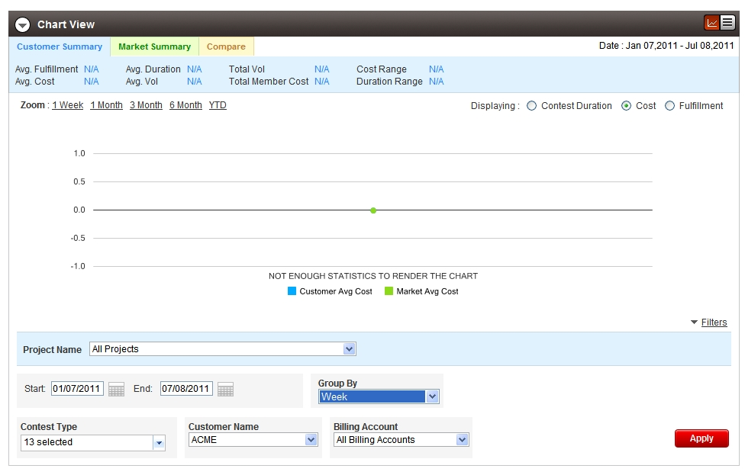

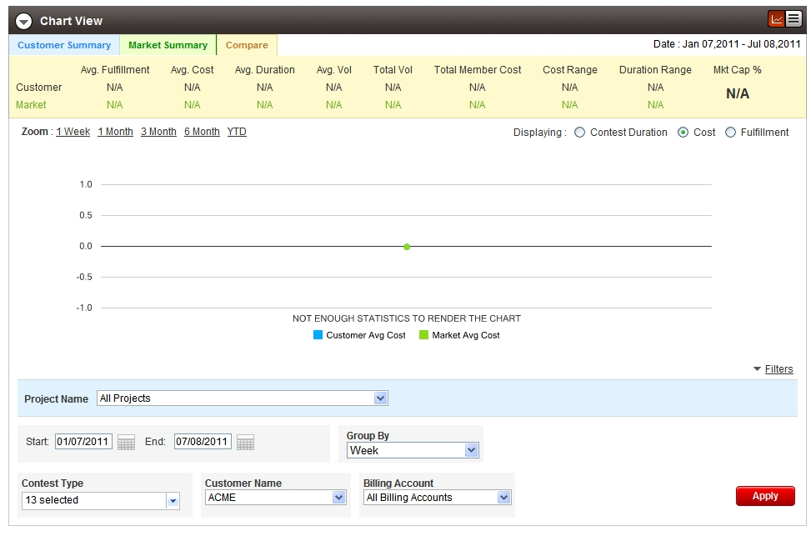
Open the filter panel, change the start date to “01/01/2008” and click the apply button. The summary panel will be updated, because there are test data in the new date range, the summary panel will have new data displayed like:

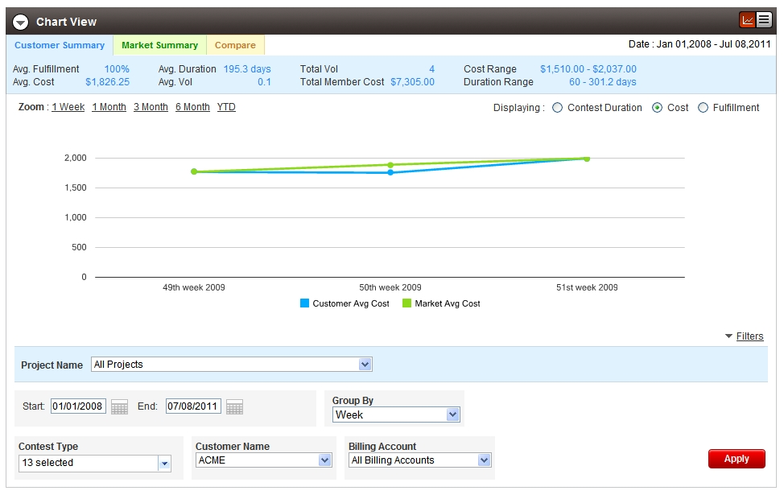

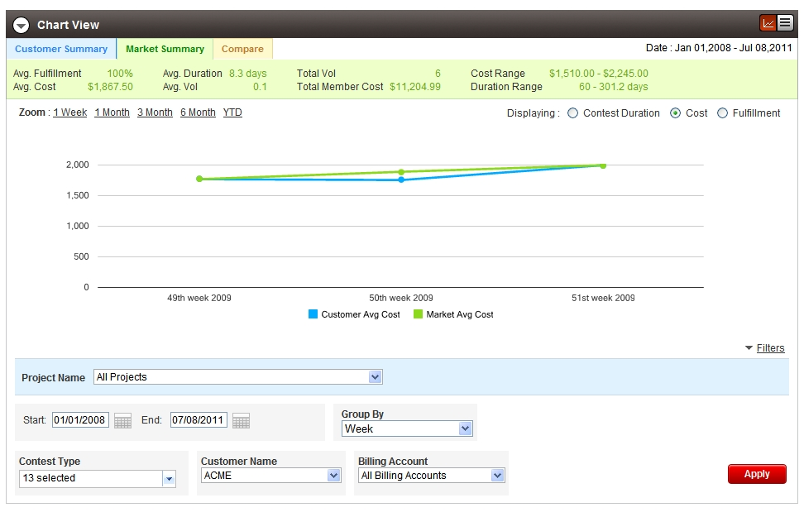

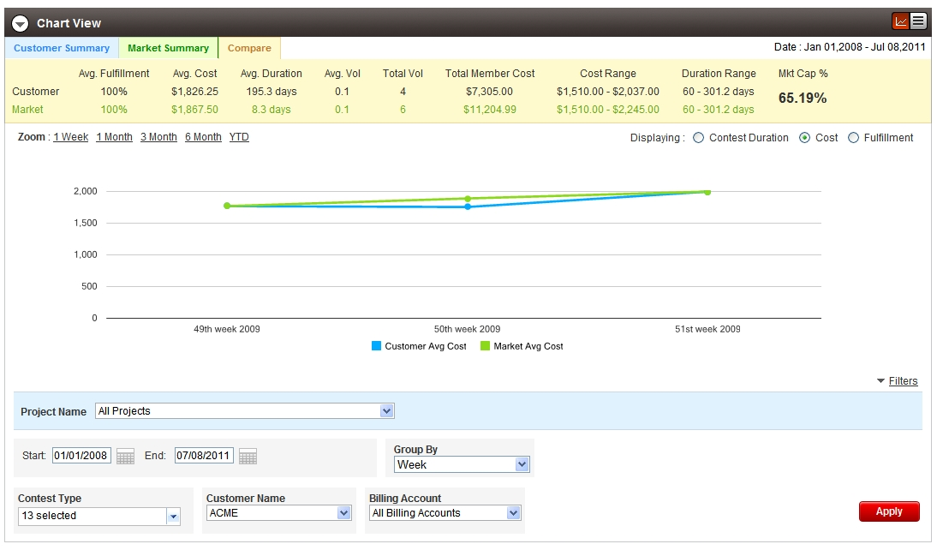

Click on a point in the chart, you can check the drill in loading GIF

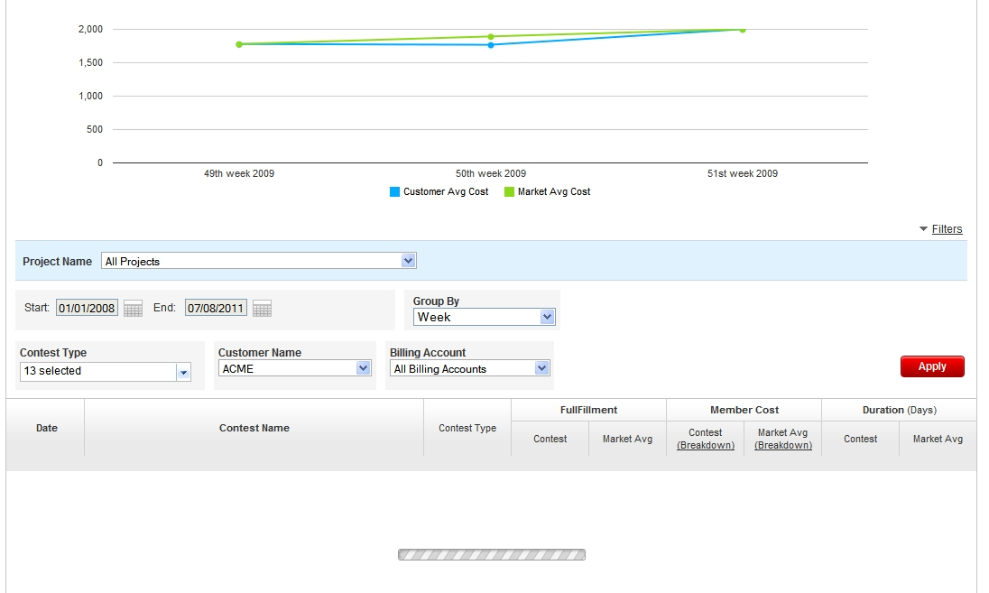

After loading finished, you can click the contest breakdown and market avg breakdown link to check breakdown loading

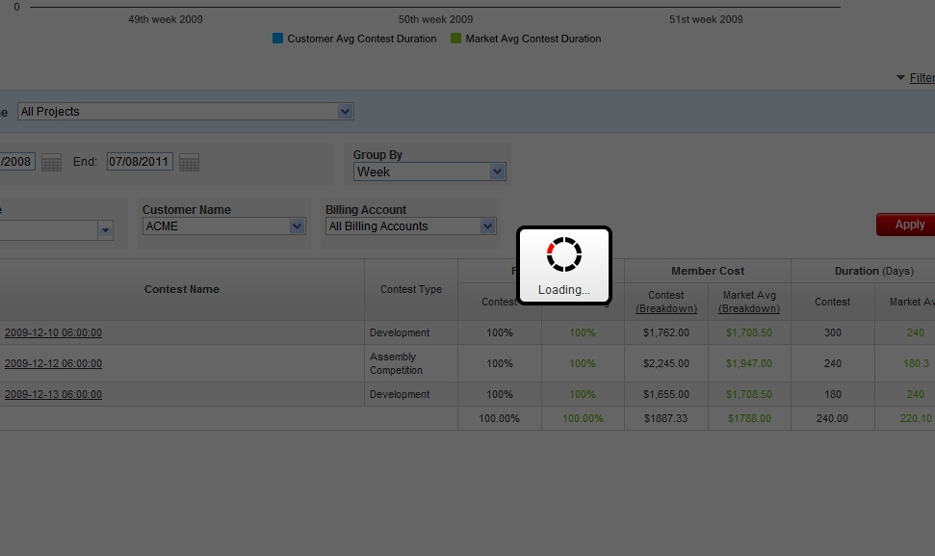

After loading, you can check the pagination layout has been fixed:

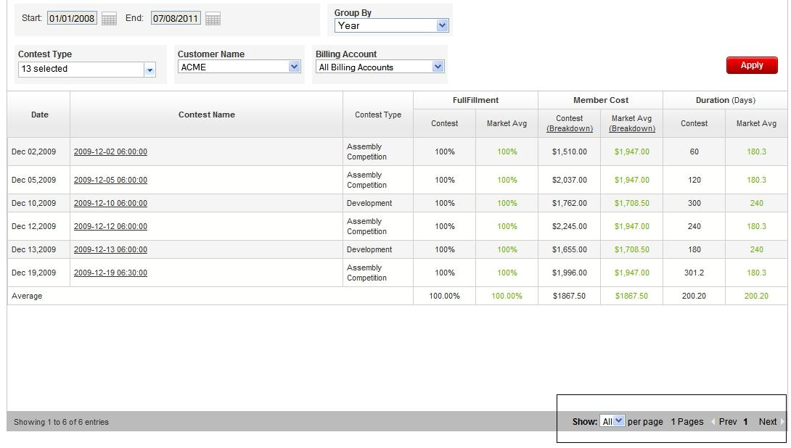

Then you can check the table view:

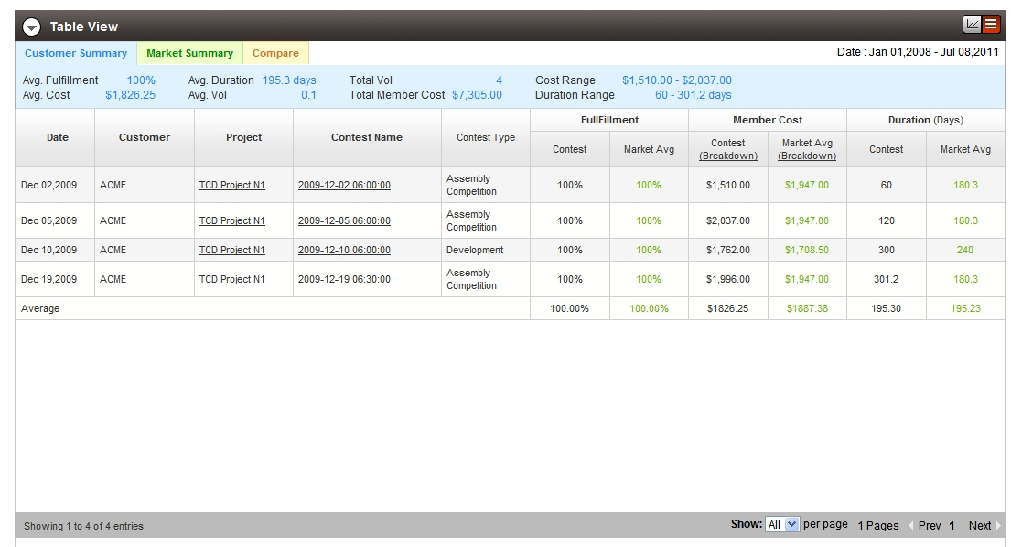

Resource Contact List

Name | Resource Email
TCSASSEMBLER

